Analysis

*This table displays the average zone of inhibition measurement for each concentration of grape seed extract calculated from the raw data.*

*(fig 1.a)*

# **DAY 1**

|  |  |
| --- | --- |
| *Concentrations of (GSPE)* | *Average zone of inhibition (mm)* |
| 1% | 5.83 |
| .75% | 5.04 |
| .5% | 3.41 |
| .25% | 2.33 |
| 0% (Water only) | 0 |

*(fig 1.b)*

# **DAY 2**

|  |  |
| --- | --- |
| *Concentrations of (GSPE)* | *Average zone of inhibition (mm)* |
| 1% | 4.29 |
| .75% | 3.29 |
| .5% | 2.46 |
| .25% | 1.13 |
| 0% (Water only) | 0 |

*(fig 1.c)*

## **DAY 3**

|  |  |
| --- | --- |
| *Concentrations of (GSPE)* | *Average zone of inhibition*  *(mm)* |
| 1% | 1.5 |
| .75% | .875 |
| .5% | .083 |
| .25% | 0 |
| 0% (Water only) | 0 |

*These tables show the average zones of inhibition for Grape Seed Extract over a 3 day period at different concentrations.*

*(fig 2.a)*

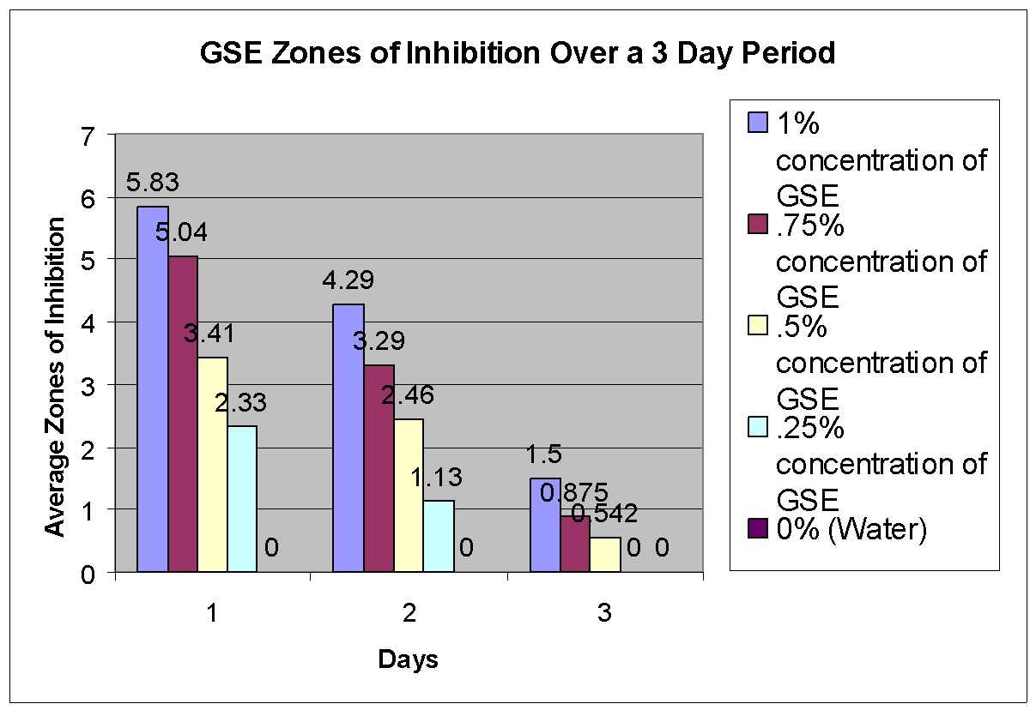

*(fig 2.b)*

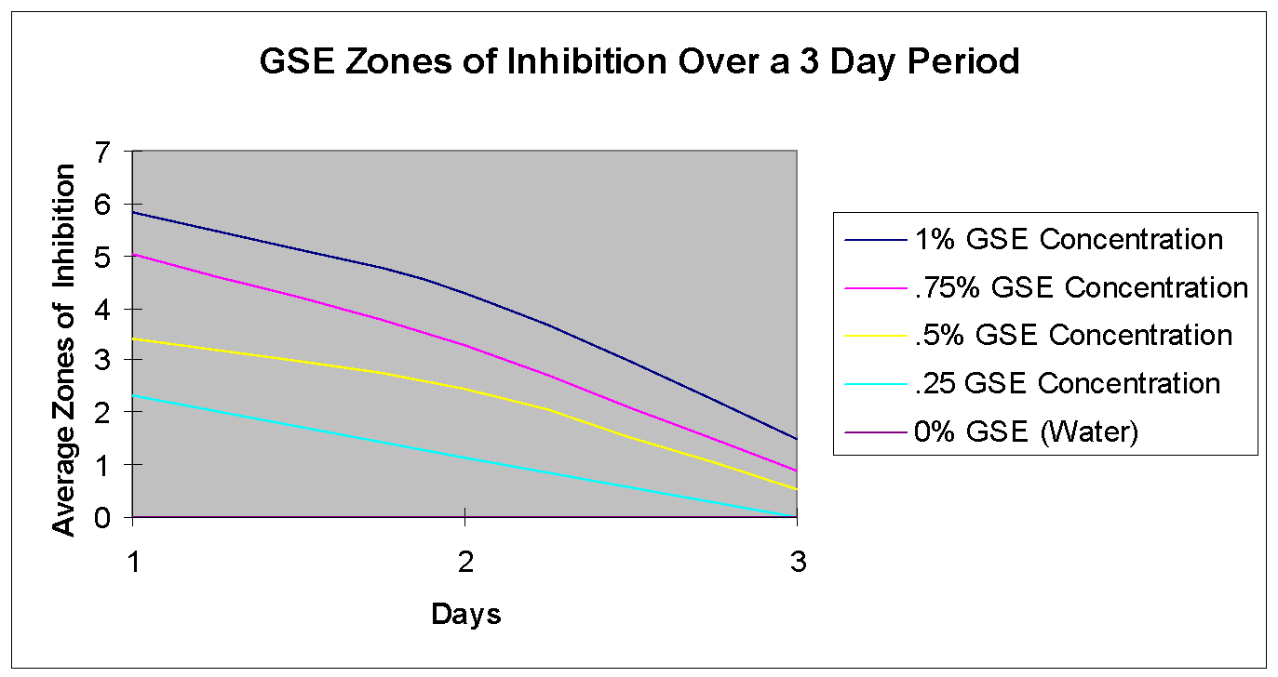

#### *This graph displays the average zone of inhibition related to the concentration of GSE for each day. Notice how the zones of inhibition decrease for each day and also have a negative correlation between the concentration and the zones of inhibition.*

*(fig 6.a)*

|  |  |  |
| --- | --- | --- |
| **Day** | **Concentration (%)** | **Avg. Zone of Inhibition (mm)** |
| **Day 1** | 1  .75  .5  .25  0 | 5.83  5.04  3.41  2.33  0 |
| **Day 2** | 1  .75  .5  .25  0 | 4.29  3.29  2.46  1.13  0 |
| **Day 3** | 1  .75  .5  .25  0 | 1.5  .875  .083  0  0 |

*(fig 6.b)*

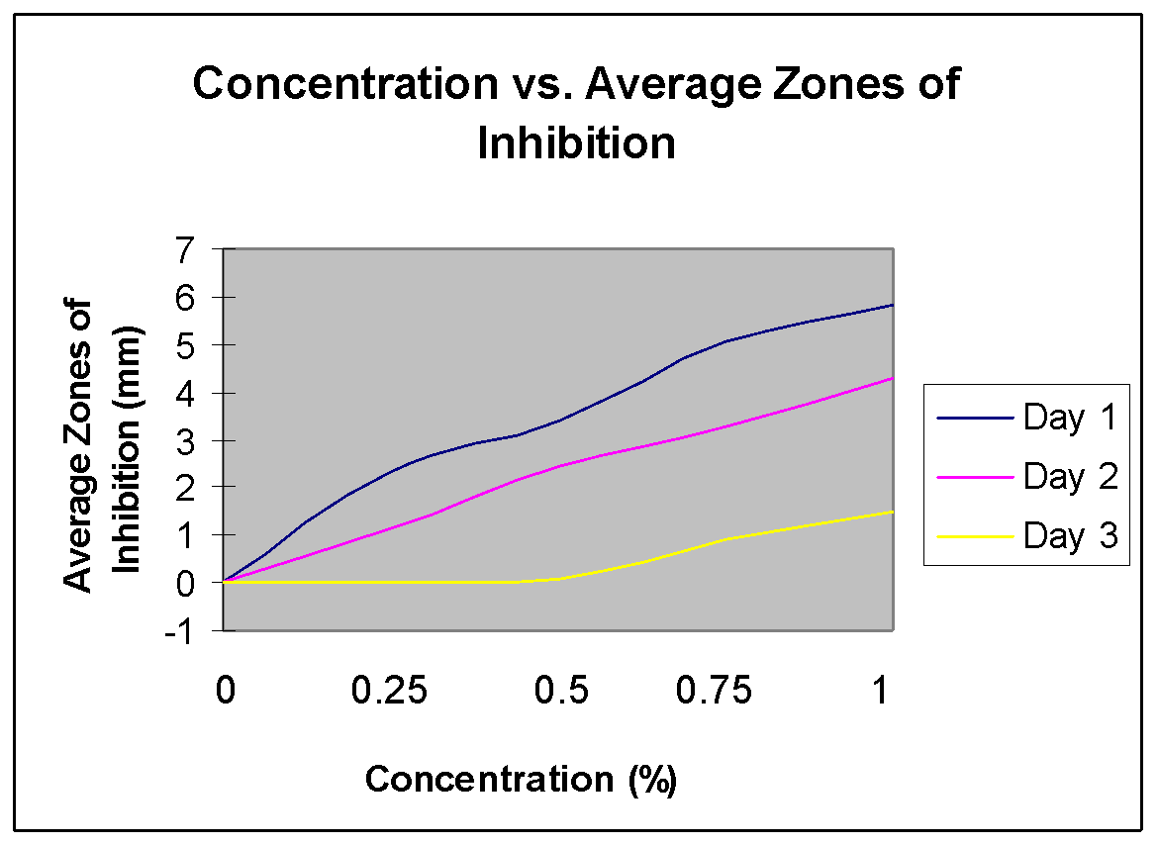

*These tables represent a 95% Confidence Interval of the zones of inhibition for each day and concentration. The Confidence Interval(CI) states that in future studies 95% of all zone averages will fall in the CI range. Each mark on the lines represent the observed averages in this study.*

*(fig 3.a)*

|  |  |
| --- | --- |
| Concentrations | 95% Confidence Interval |
| 1% | 5.83 +/- 0.426 |
| .75% | 5.04 +/- 0.643 |
| .5% | 3.41 +/- 0.537 |
| .25% | 2.33 +/- 0.424 |

*(fig 3.b)*

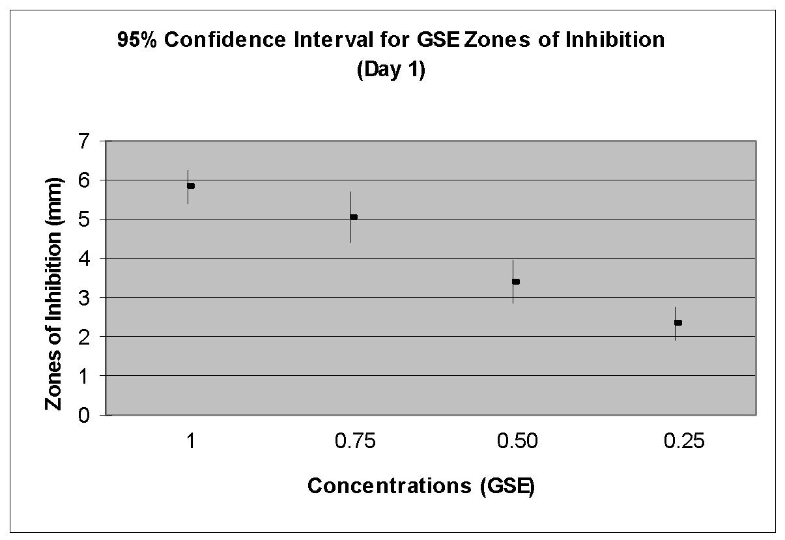

*(fig 4.a)*

|  |  |
| --- | --- |
| Concentrations | 95% Confidence Interval |
| 1% | 4.29+/- 0.6846 |
| .75% | 3.29 +/- 0.643 |
| .5% | 2.46 +/- 0.596 |
| .25% | 1.13 +/- 0.299 |

*(fig 4.b)*

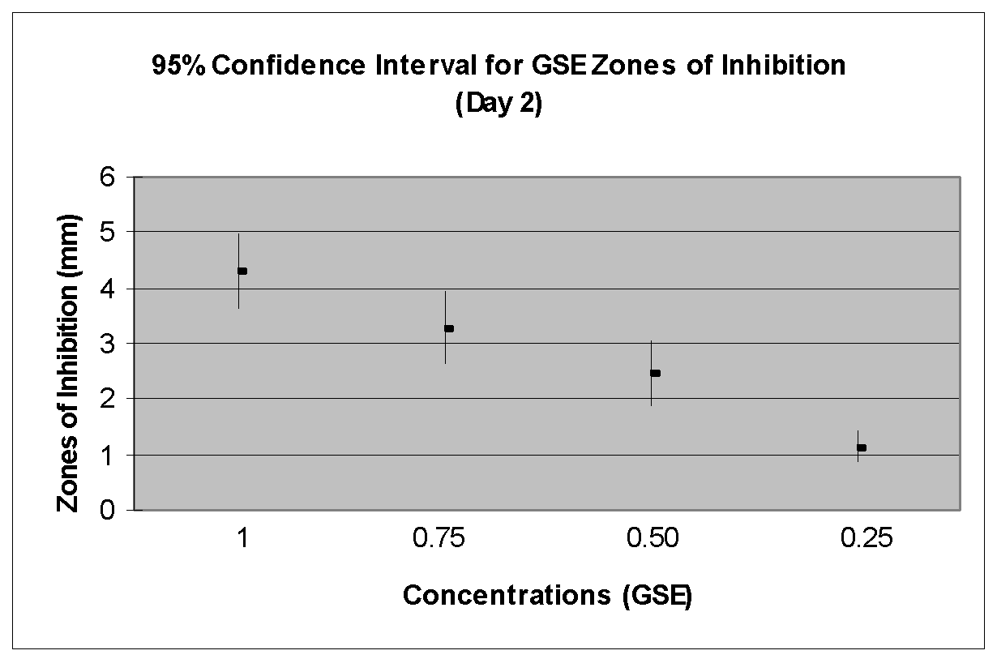

*_____________________________________________________________________________*

*(fig 5.a)*

|  |  |
| --- | --- |
| Concentrations | 95% Confidence Interval |
| 1% | 1.5 +/- 0.603 |
| .75% | 0.875 +/- 0.639 |
| .5% | 0.083 +/- 0.562 |
| .25% | 0 (no zones of Inhibition) |

*(fig 5.b)*

